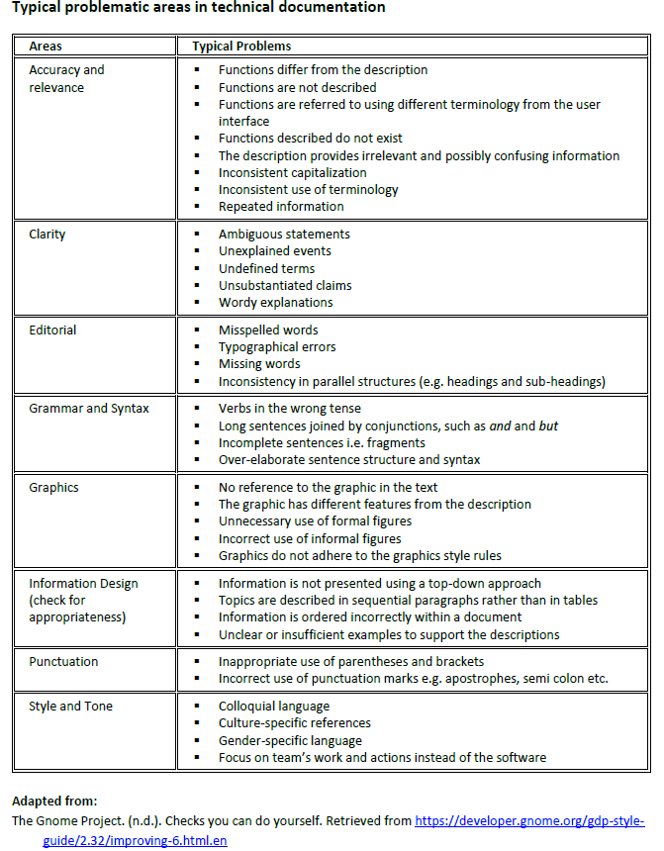

**User Guide Checklist**

|  |  |
| --- | --- |
| **Quality characteristics and guidelines** | **Comments** |
| **INTRODUCTION**   * Is there a brief overview of the software and its functions (what it can do for the user)? * Is the purpose of the user guide clearly stated? * Is the target reader identified and addressed? |  |
| **SECTIONS OF THE USER GUIDE**  Has all relevant information been included?   * A quick start / getting started section that guides a new user to do some basic useful things. * A detailed manual of functionality * Optionally, a 'cheat sheet' with a compact summary of features targeting seasoned users. * Is the information presented in an appropriately hierarchical order? * Is information repeated only when needed? |  |
| **INSTRUCTIONS**   * Are instructions clear and easy to follow? * Are there sufficient examples and graphics to illustrate the instructions, where relevant and necessary? |  |
| **PRESENTATION & GRAPHICS**   * Are graphics neat, attractive and easy to understand? * Do graphics effectively complement the text description? * Can the reader easily distinguish the point of each graphic and which text it corresponds to? * Have specific references to graphics been made in the commentary, where necessary? * Are formal graphics labelled appropriately? Is the format standardized? * Is the table of contents of the user guide effective and user-friendly? * Is the layout of the entire guide appealing and user-friendly? Is there sufficient white space? * Have mechanics been used effectively to differentiate headings of different levels? Is there consistency in the way the headings and sub-headings are presented? * Are the headings and sub-headings relevant, informative and concise? |  |
| **LANGUAGE, STYLE AND TONE**   * Is grammar correct and accurate? * Are transitional devices used appropriately to provide coherence to the whole report? * Is the writing clear, direct and easy to read? * Is the writing concise? Can unnecessary words/phrases be deleted? * Is an appropriate style and level of formality used? * Is the tone appropriate (welcoming, friendly, approachable, professional vs cold, distant, clinical, too casual) and consistent throughout the document? * Is the level of technicality suitable for the intended reader? * Does it address the reader directly? |  |